EXERCISE-33

33.Design DFA using simulator to accept even number of c’s over the set

{a,b,c}

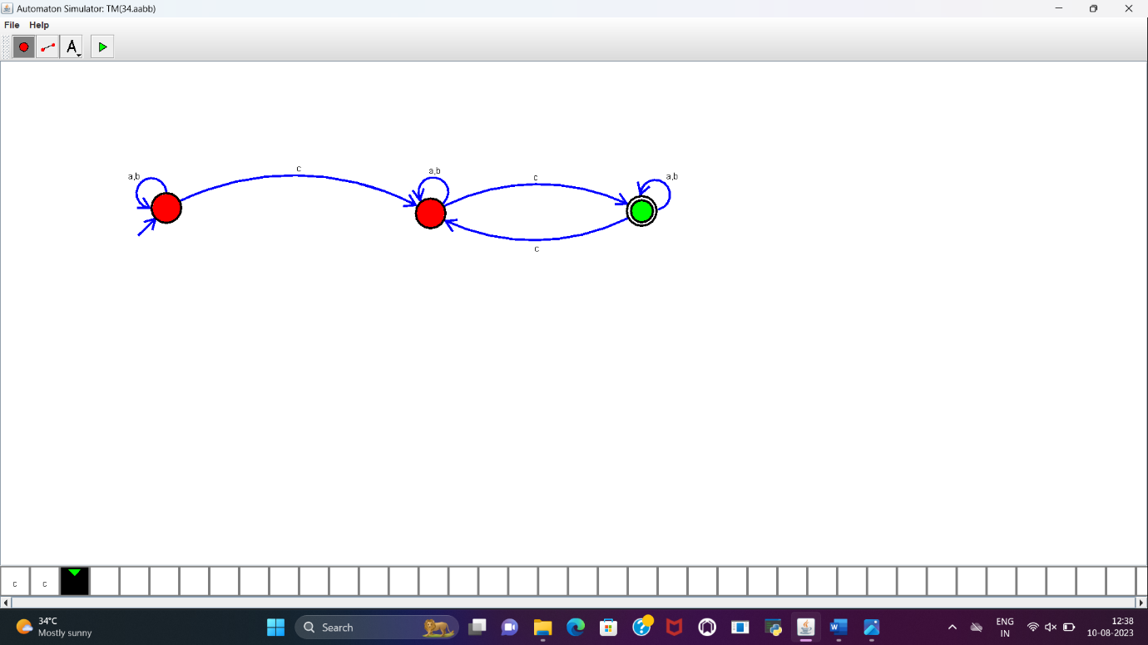

RESULT:

DFA to accept even number of c’s over the set of {a,b,c} is designed and implemented successfully using simulator.